THE PTI 2016/2017 LONG SERVICE AWARD CEREMONY

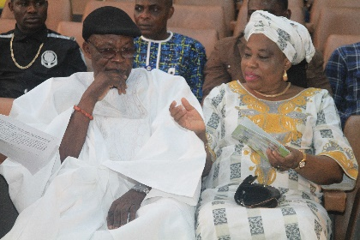

Cross session of guests.

Chief Victor T. Ewere and the former Registrar, Mrs. Angela S. Ewere.

Faces of guest at the event.

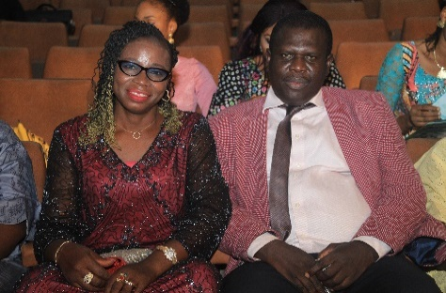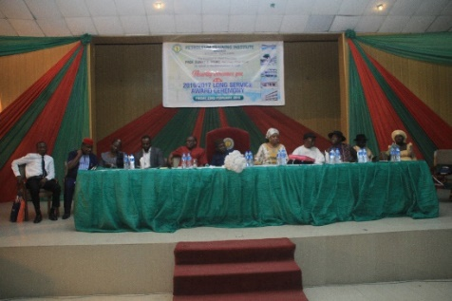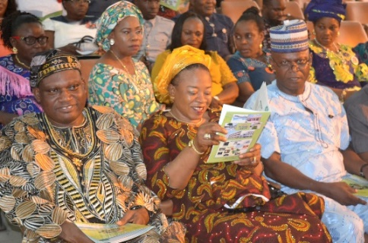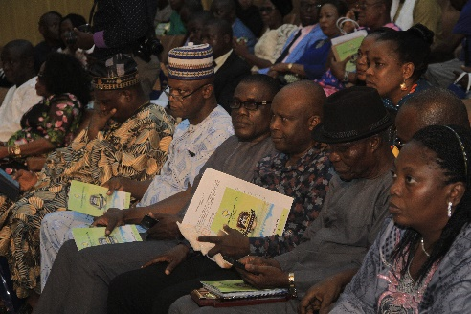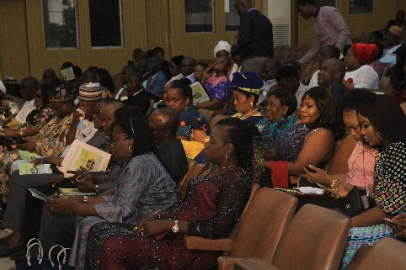

Principal & Chief Executive, Prof. Sunny E. Iyuke (middle) flanked by Management and the Institute’s guests.

Assistant Director/Head Public Affairs, Mr. Brown A. Ukanefimoni and his wife, Paradise feeling cool.

Mr. A.I. Uwagboe, Mrs. H.T.S. Momoh and Mr. S.N. Yugbovwre.

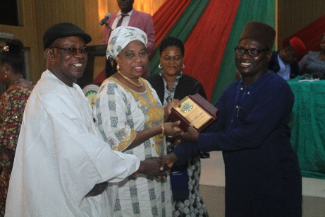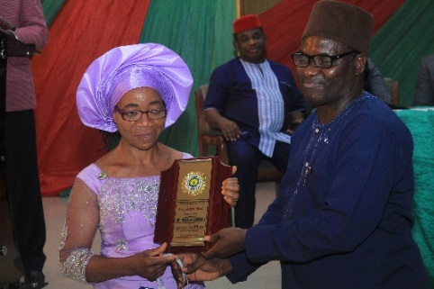

Principal & Chief Executive, Prof. Sunny E. Iyuke presenting 35yrs meritorious service award to the former Registrar, Mrs. Angela S. Ewere sided by the husband, Chief V.T. Ewere.

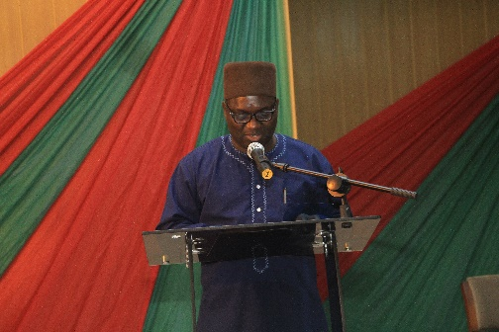

Principal & Chief Executive, Prof. S.E. Iyuke presenting 35yrs meritorious service award to Mrs. M. Nneji (Rtd).

Principal & Chief Executive, Prof. Sunny E. Iyuke presenting his welcome address.

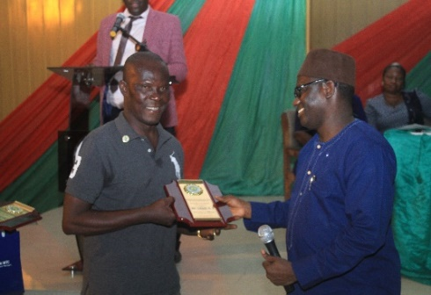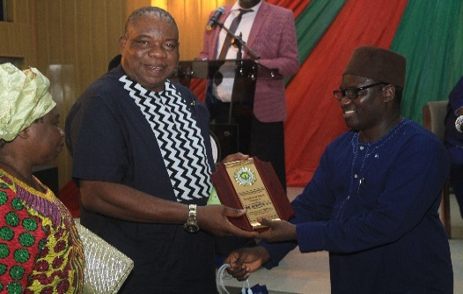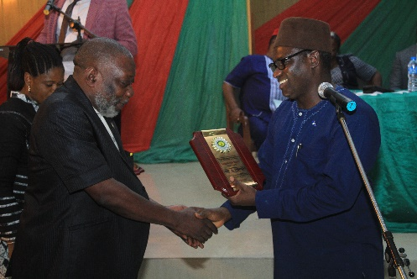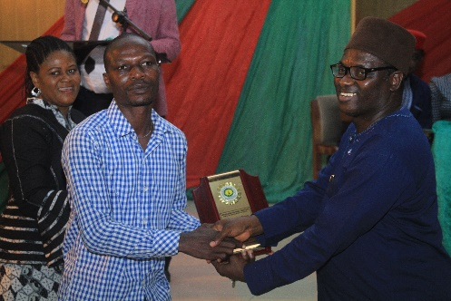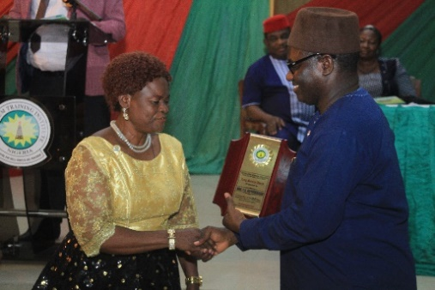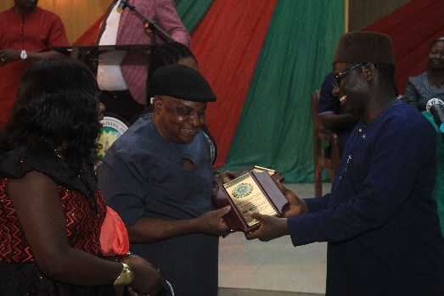

Principal & Chief Executive, Prof. S.E. Iyuke presenting 35yrs meritorious service award to Mr. B.U. Onaiwu (Rtd).

Principal & Chief Executive, Prof. S.E. Iyuke presenting 35yrs meritorious service award to Mr. Orido, the son of Mr. S. Orido (Rtd).

Principal & Chief Executive, Prof. S.E. Iyuke presenting 35yrs meritorious award to Mrs. C.O. Akpovhekaire (Rtd).

Principal & Chief Executive, Prof. S.E. Iyuke presenting 35yrs meritorious service award to Mr. M.E. Omare (Rtd).

Principal & Chief Executive, Prof. S.E. Iyuke presenting 35yrs meritorious award to Mr. A.C. Agwuibe (Rtd).

Principal & Chief Executive, Prof. S.E. Iyuke presenting 35yrs meritorious service award to Mr. C. Ohwoekevbo (Rtd).

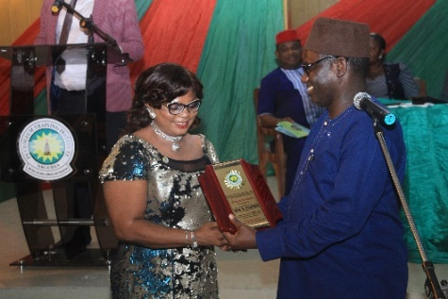

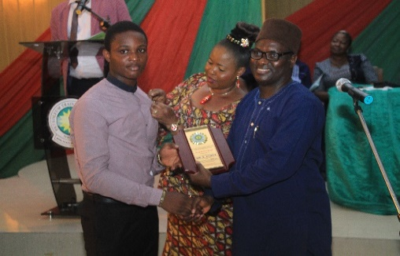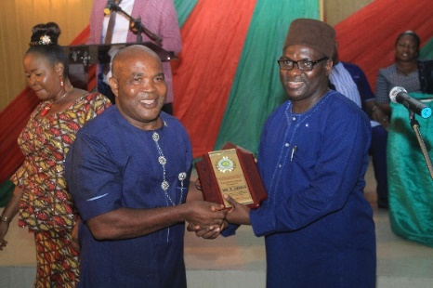

Principal & Chief Executive, Prof. S.E. Iyuke presenting Post Humous Award to the son of late Mr. B. Atikpe.

Principal & Chief Executive, Prof. S.E. Iyuke presenting 35yrs meritorious service award to Mr. E. Okolo (Rtd).

Principal & Chief Executive, Prof. S.E. Iyuke presenting 35yrs meritorious service award to Mrs. R. Onofere (Rtd).

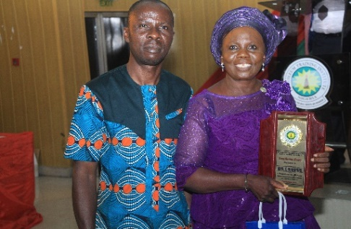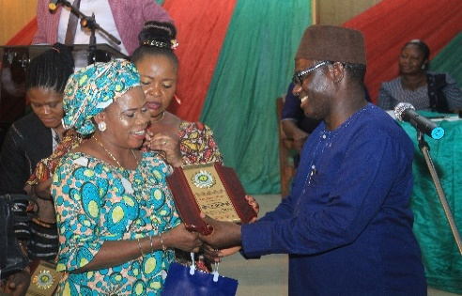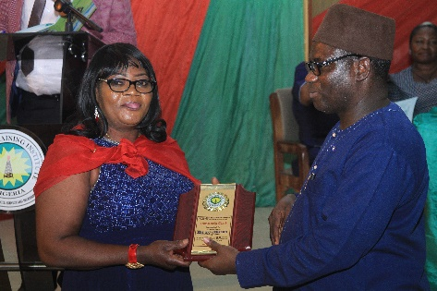

Principal & Chief Executive, Prof. S.E. Iyuke presenting 35yrs meritorious service award to Mrs. E.O. Okonkwo (Rtd).

Mrs. F. Isiakpere (Retd) flanked by her son, displaying her 35yrs meritorious service award plaque.

Principal & Chief Executive, Prof. S.E. Iyuke presenting 35yrs meritorious service award to Mrs. B. Ogunna (Rtd).

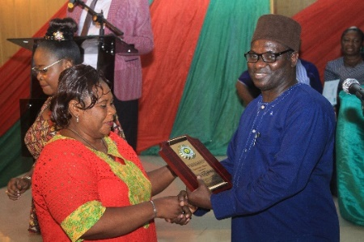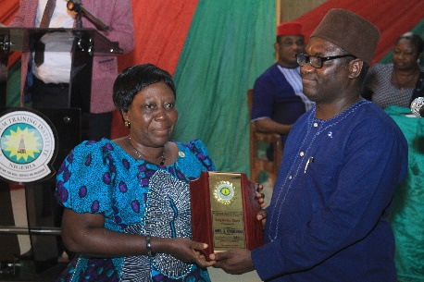

Principal & Chief Executive, Prof. S.E. Iyuke presenting 35yrs meritorious service award to Mrs. A. Onokpasa.

Principal & Chief Executive, Prof. S.E. Iyuke presenting 35yrs meritorious service award to Mrs. R. Achakpekri (Rtd).

Principal & Chief Executive, Prof. S.E. Iyuke presenting 35yrs meritorious service award to Mr. M. Otite.

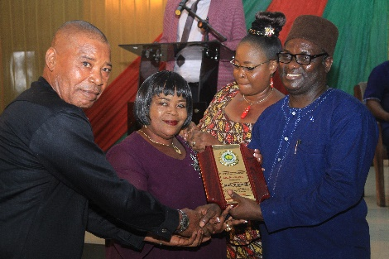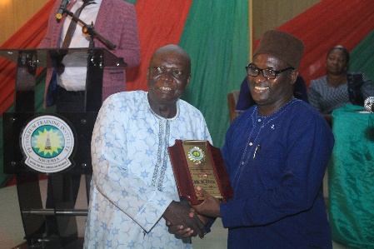

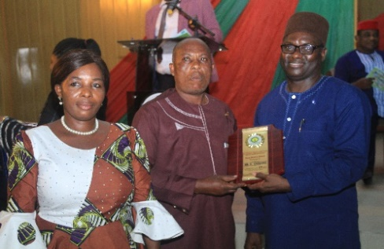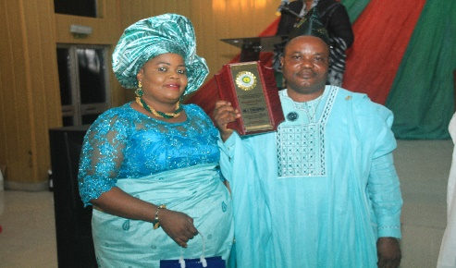

Principal & Chief Executive, Prof. S.E. Iyuke presenting 35yrs meritorious service award to Mr. B. Onogoro sided by his wife.

Principal & Chief Executive, Prof. S.E. Iyuke presenting 35yrs meritorious service award to Mrs. P. Abaje sided by her husband.

Mr. Friday Evbuomwan sided by his wife, displaying his 30yrs meritorious service award plaque.

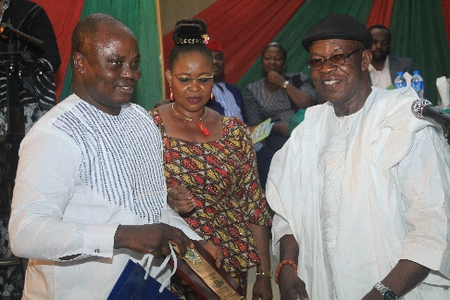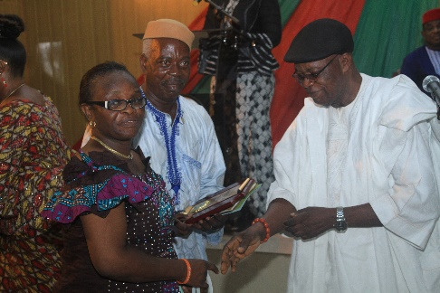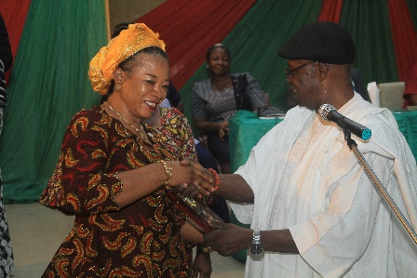

Mrs. H.T.S. Momoh cheerfully receives her 30yrs meritorious service award from Chief V.T. Ewere.

Mr. O. Efeke receiving his 30yrs meritorious service award from Chief Victor T. Ewere.

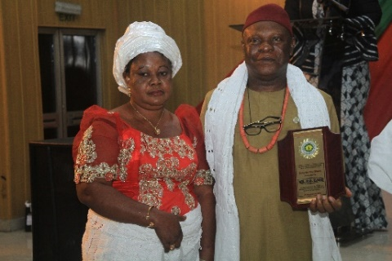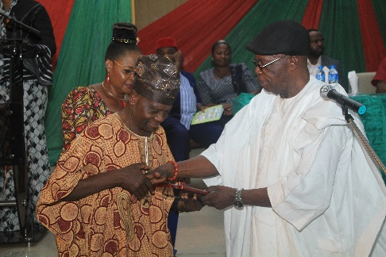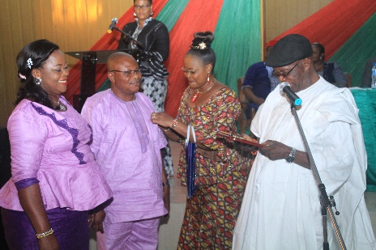

Mr. J. Ajisafe, sided by his wife receiving his 30yrs meritorious service award from Chief V.T. Ewere.

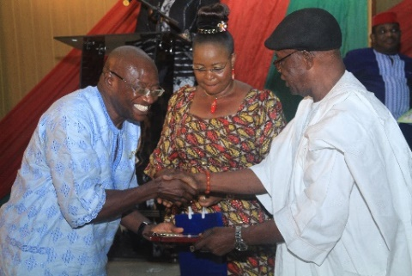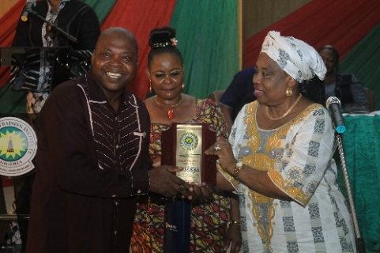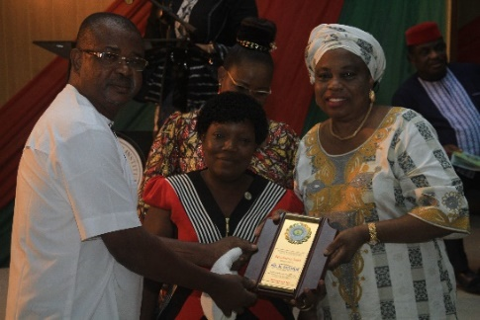

Chief V.T. Ewere presenting 30yrs meritorious service award plaque to Mr. J.O. Fadojutimi.

Mr. P.O. Ejoh sided by his wife as he displayed his 30yrs meritorious service award plaque.

Chief V.T. Ewere presenting 30yrs meritorious service award to Mr. D. Ebegba sided by his wife.

Mr. J. Odogun cheerfully receiving his 30yrs meritorious service award from the former Registrar, Mrs. A.S. Ewere.

Mr. F.O. Omagbemi joyously receiving his 30yrs meritorious service award from Chief V.T. Ewere.

The former Registrar, Mrs. A.S. Ewere presenting 30yrs meritorious service award plaque to Mrs. M. Ogumor sided by the husband.

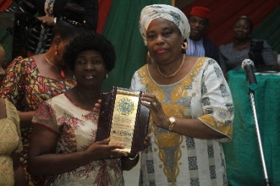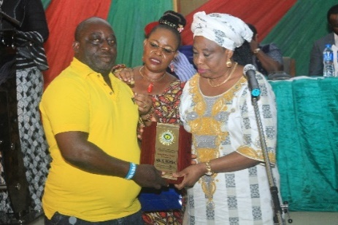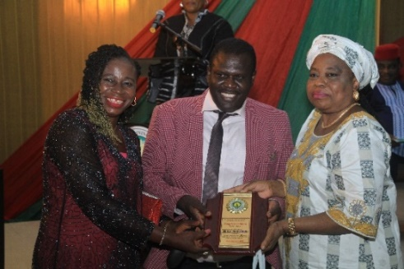

The former Registrar, Mrs. A.S. Ewere presenting 30yrs meritorious service award plaque to Mr. E. Idjesa.

The former Registrar, Mrs. A.S. Ewere presenting 30yrs meritorious service award plaque to Mrs. P. Apuamaga.

The former Registrar, Mrs. A.S. Ewere presenting 30yrs meritorious service award plaque to Mr. Brown A. Ukanefimoni, sided by his wife Paradise.

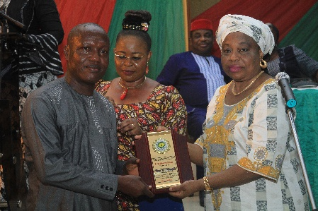

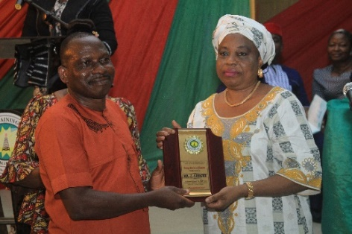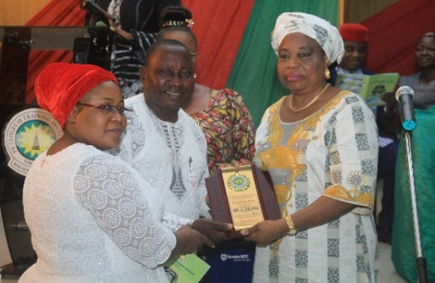

The former Registrar, Mrs. A.S. Ewere presenting 30yrs meritorious service award plaque to Mr. G. Ekama sided by his wife.

The former Registrar, Mrs. A.S. Ewere presenting 30yrs meritorious service award plaque to Mr. J. Adoghe.

Engr. W. Odinikuku receiving his 30yrs meritorious service award plaque from the former Registrar, Mrs. A.S. Ewere.

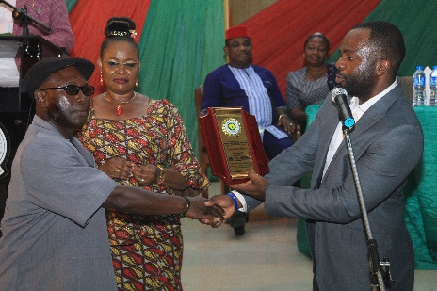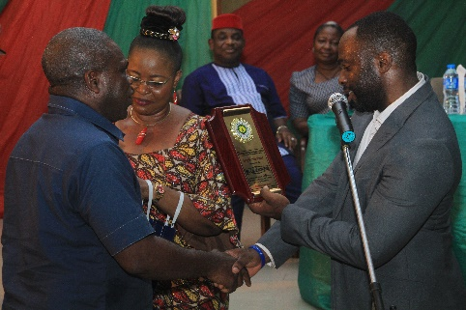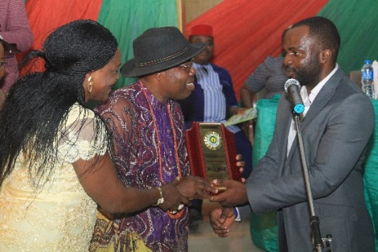

Mr. C.O. Jarikre receiving his 25yrs meritorious service award from the Manager Public Affairs, Stanbic IBTC Pensions, Mr. Rotimi

Mr. C.U. Ochonogor, receiving his 25yrs meritorious service award from the Manager Public Affairs, Stanbic IBTC Pensions, Mr. Rotimi.

Director OTC, Dr. Clement K. Oghene sided by his wife Abigail, receiving his 25yrs meritorious service award plaque from the Manager, Public Affairs, Stanbic IBTC Pensions, Mr. Rotimi.

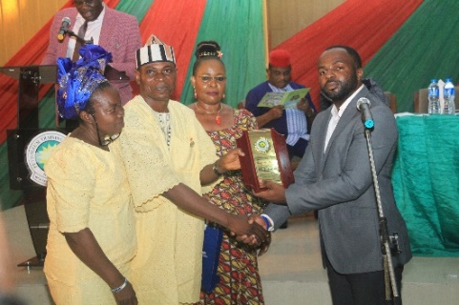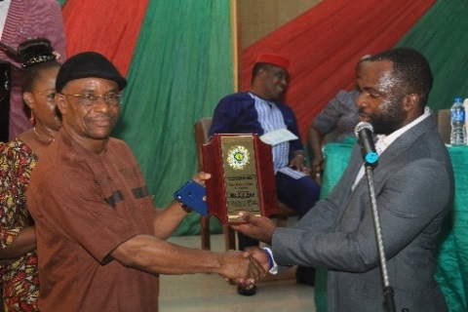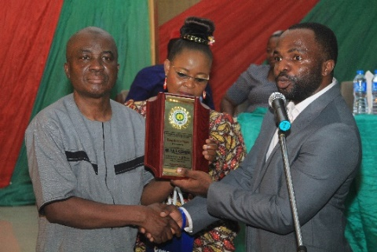

Mr. S.N.O. Ozonuwe being presented with his 25yrs meritorious service award by the Manager, Public Affairs, Stanbic IBTC Pensions, Mr. Rotimi.

Dr. S. Agaja sided by his wife, receiving his 25yrs meritorious service award from the Manager, Public Affairs, Stanbic IBTC Pensions, Mr. Rotimi.

The Manager, Public Affairs, Stanbic IBTC Pensions, Mr. Rotimi presenting the 25yrs meritorious service award to Dr. E.U. Eke.

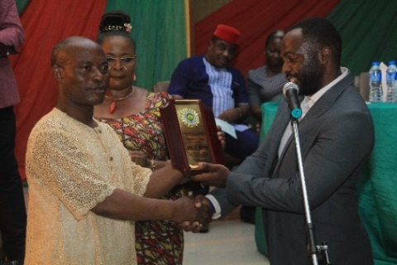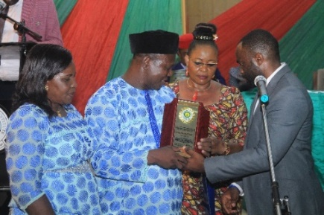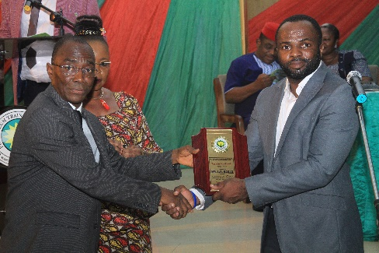

Engr. J.O. Umukoro receiving his 25yrs meritorious service award from the Manager Public Affairs, Stanbic IBTC Pensions, Mr. Rotimi.

The Manager Public Affairs, Stanbic IBTC Pensions, Mr. Rotimi presenting the 25yrs meritorious service award to Engr. D.M. Enweliku sided by his wife.

Mr. L.O. Banjo receiving his 25yrs meritorious service award from the Manager, Public Affairs, Stanbic IBTC Pensions, Mr. Rotimi.

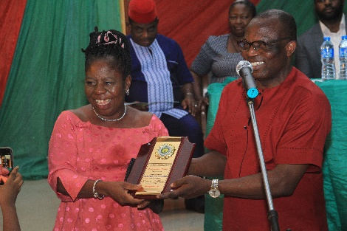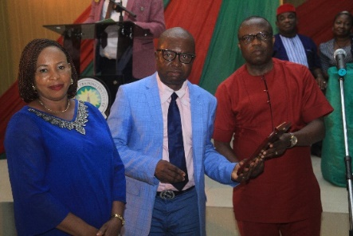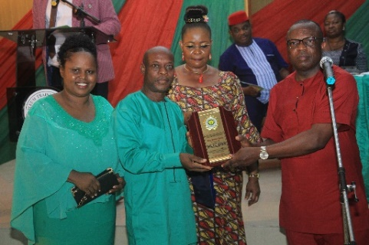

Engr. (Mrs.) G.O. Erhimona joyously receiving her 25yrs meritorious service award from the Ag. Registrar, Mr. O.C. Siakpere.

The Ag. Registrar, Mr. O.C. Siakpere presenting the 25yrs meritorious service award to Mr. I.L. Oyem sided by his wife.

Mr. L.O. Aselimen, sided by his wife receiving his 25yrs meritorious service award from the Ag. Registrar, Mr. O.C. Siakpere.

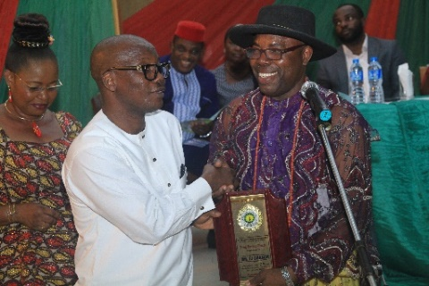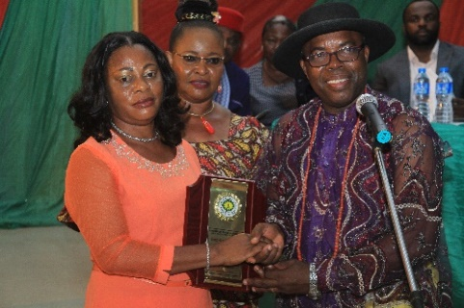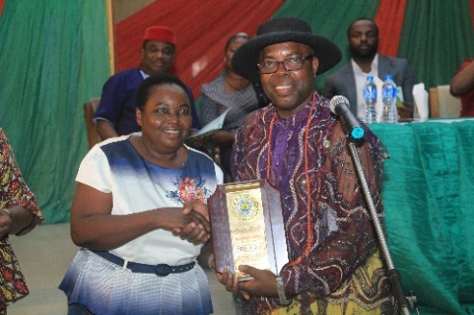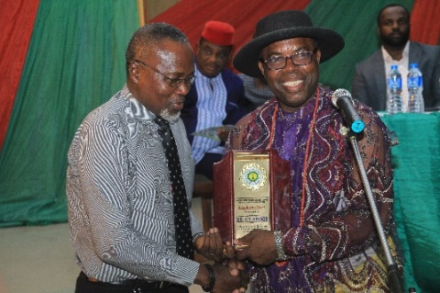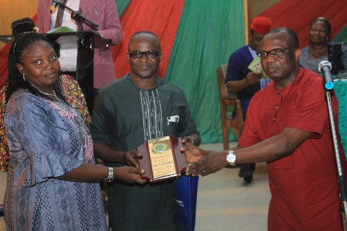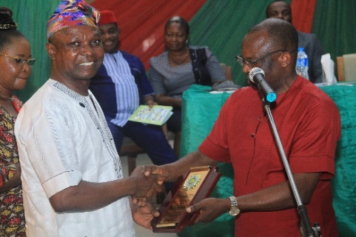

Mr. F.I. Obanor receiving his 25yrs meritorious service award from the Director OTC, Dr. C.K. Oghene.

Mrs. B. Uweja receiving her 25yrs meritorious service award from the the Director OTC, Dr. C.K. Oghene.

Mrs. A. Oji receiving her 25yrs meritorious service award from the Director OTC, Dr. C.K. Oghene.

Mr. V.T. Abigor receiving his 25yrs meritorious service award from the Director OTC, Dr. C.K. Oghene.

Mr. D. Yohanna, sided by his wife receiving his 25yrs meritorious service award from the Ag. Registrar, Mr. O.C. Siakpere

The Ag. Registrar, Mr. O.C. Siakpere presenting the 25yrs meritorious service award plaque to Mr. G.A. Ifajeunnu.

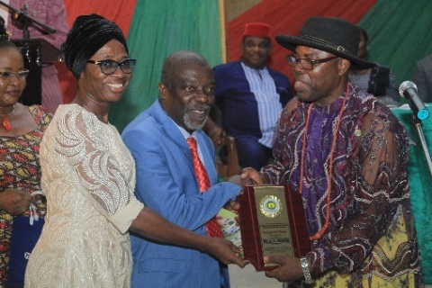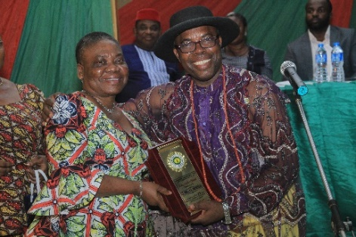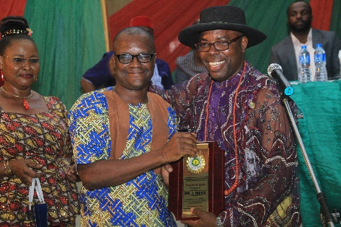

Mr. A.E. Ogbodo, sided by his wife receiving his 25yrs meritorious service award from the Director of OTC, Dr. C.K. Oghene.

Dr. (Mrs.) O.A. Omorodion receiving her 25yrs meritorious service award from the Director of OTC, Dr. C.K. Oghene.

Mr. I. Mega receiving his 25yrs meritorious service award from the Director OTC, Dr. C.K. Oghene.